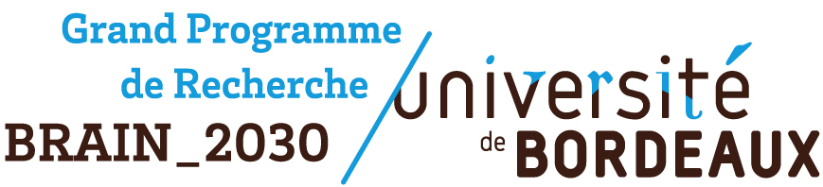
PhD Extension Grant 2026

Application Guidelines

Objectives
The GPR BRAIN_2030 offers a fellowship to students from Bordeaux Neurocampus to support the completion of their PhD thesis work, either prior to or following thesis defense.
The fellowship aims to provide temporary financial support to facilitate the finalization and valorization of research projects through either:
- Funding of a fourth year of PhD
- Short-term postdoctoral employment to complete ongoing research before leaving the laboratory

Eligibility criteria
Applicants must meet the following conditions:
- The PhD research must be conducted within a Bordeaux Neurocampus institute
- Eligible candidates are currently in their 3rd year of PhD and wish to:
- Extend their 3rd year and/or start a post-doctoral position
- Complete a 4th year of PhD
- The fellowship is limited to:
- A maximum duration of 12 months
- Funding not exceeding the equivalent of one year of PhD salary

Evaluation criteria
Applications will be assessed according to scientific and academic excellence criteria, including:
- Career trajectory and professional development plan
- Overall quality of the application (clarity, conciseness, adherence to the provided template)
- Scientific quality of the proposed work plan (progress already achieved during the thesis, feasibility and robustness of the completion strategy)
- Potential for high-impact scientific publications and research valorization
Applications will be evaluated by the coordinators and co-coordinators of the GPR BRAIN_2030.

Submission
Applications must be submitted by email to: julia.goncalves@u-bordeaux.fr
Submission requirements:
- Single PDF file
- Excluding the first page containing instructions
Submission deadline:
Wednesday, April 1st, 2026 at 11:00 am (strict deadline — late submissions will not be considered)

The list of awardees will be communicated by email and published on the Bordeaux Neurocampus website on Thursday, April 30th, 2026.

PhD Extension Grant 2026

Application Form

Administrative information

Last name:

First name:

Institute:

Team leader(s):

PhD supervisor:

Title of the PhD project:

Start and end dates of the PhD contract:

Grant requested to the GPR BRAIN_2030

Start and end dates of requested grant:

Total number of months requested:

Number of PhD months:

Number of post-doc months:

Proposed date for the PhD defense:

Current funding

Precise description of current PhD funding (MNRT, ANR, FRM, ITN, ERC, CIFRE, FELLOWSHIP, etc…):
- Start and end dates of the grant:
- Funding agency:
- Name of the PI:
- Title of the grant project:

Other requested grants

- Funding agency:

Total number of months requested:

Number of PhD months:

Number of post-doc months:
- Answer date:
- Answer if known:

Abstract
  - (250 words max)

Description of the accomplished experiments and obtained results
  - (300 words + figures if needed, 100 words max per caption, 1 page max for figures)

Workplan (objectives, methods, timeline, expected results)
  - (300 words + figures if needed, 100 words max per caption, 1 page max for figures)

Career plan (submitted grant for PhD completion, indication on next step of your career: active search for a post-doc, a job in the industry, a reorientation …)
  - (1 page max)

Curriculum vitae (including fellowship obtained for the first 3 years and publication list: published, submitted, and in progress)
  - (2-3 pages max)

