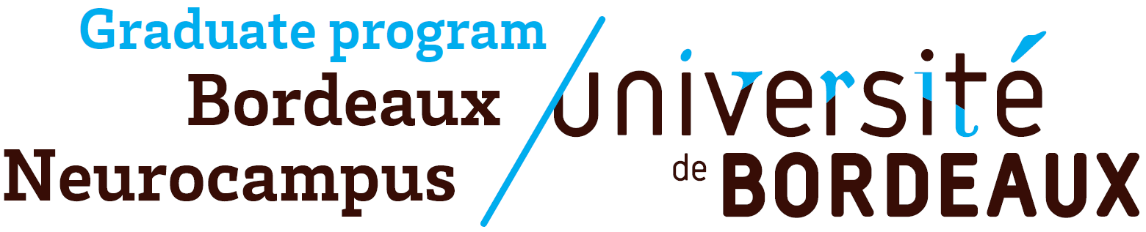


CALL FOR PROPOSAL

Bordeaux Neurocampus Doctoral Research Awards 2026

OBJECTIVES

The Bordeaux Neurocampus department and the Bordeaux Neurocampus Graduate Program launch the 6th call for proposal in order to reward outstanding doctoral research in Neuroscience.

Ph.D. students will be invited to present their effective Ph.D. work to the whole community of Bordeaux Neurocampus on June 24th 2026, either with:
- A poster presentation: open to all PhD students, “first-come first-served”, 30 persons maximum
- An oral presentation: only for selected PhD students members of the Department Council and Graduate Program executive board will pre-select in May 2026 the best applications for oral presentation. The winners will be then awarded 3 cash prizes of €300.

ELIGIBILITY CRITERIA

- Participants should be PhD students enrolled in one of the Doctoral Schools of the University of Bordeaux and working in one of the Bordeaux Neurocampus department laboratories.
- For the duration of their thesis, PhD students will be allowed to give only one oral presentation.

SELECTION CRITERIA FOR THE PRE-SELECTION

- Significance and clarity of the research proposal
- Appropriateness of the methodology

- Quality of the data
- Positioning / impact of the work in the scientific field

EVALUATION CRITERIA FOR THE AWARD

- Objectives and scientific hypotheses
- Impact and significance of the results
- Pedagogy and quality of the visual support

SUBMISSION

Applications must be submitted by email to: aap.neurocampus@u-bordeaux.fr
Submission requirements: single PDF file, excluding the first page containing instructions.
Submission deadline: Thursday, May 21st, 2026 at 2:00 PM (late submissions will not be considered).

CALL FOR PROPOSAL

Bordeaux Neurocampus Doctoral Research Awards 2026

LAST NAME:
FIRST NAME:
INSTITUTE:
TEAM LEADER:
THESIS SUPERVISOR:
PROJECT TITLE:
YEAR OF PHD: ☐ 1st year ☐ 2nd year ☐ 3rd year ☐ 4th year

EXPRESS YOUR CHOICE:
☐ I would like to give an oral presentation
( if I am not selected, I would like to present a poster: ☐ Yes / ☐ No)
☐ I would like to present a poster

ABSTRACT (250 words max)

PROJECT DESCRIPTION & SUMMARY OF THE WORK ACCOMPLISHED (2 pages max + 1 figure max)

(Impact of the work / situation of the work in the scientific environment)

BIBLIOGRAPHY (1 page max)
(List the main bibliographic references supporting your project. Do not include your own publications here; personal publications, if relevant, should be included in the CV section only)

CURRICULUM VITAE (2 pages max)

